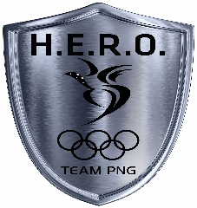
TEAM PNG HERO APPLICATION
Name of Athlete: | Sport:
Date of Birth: | Gender (M/F):
Postal Address: | Home Address:
Phone number: | Email address:

Briefly describe your sporting history, indicating the times you have represented PNG and the highest level of achievement.

Do you have any experience in presenting to an audience? If so, please state.

Describe the personal goals you have set for the next five years.

From a rating of 1-3, please rate the following possible skills that are of importance and that you want to learn more about. (1- not at all important,
2- somewhat important, 3- very important)

Topic | Rating (Please circle)
Time Management | 1 2 3
Public Speaking | 1 2 3
Media Interviews | 1 2 3
CV Writing | 1 2 3
Networking | 1 2 3
Letter writing | 1 2 3
Sponsorship Proposal | 1 2 3
Social Media (the good and the bad) | 1 2 3

Please indicate what topic interests you.
Olympic Values Environment (Love Your Coast)
Gender Equality Non-Violence
Sustainable Development Goals Anti-Doping Other

To be a TEAM PNG HERO you will be required to participate for the full five days of training. The training is scheduled on November 16th-20th 2020. Daily sessions start at 8:30am and ends at 3:30pm.

Deadline for application submission is on Monday November 9th, 2020.

For Official Use only
Comments:

Athlete Applicant Signature

National Federation Executive Signature

