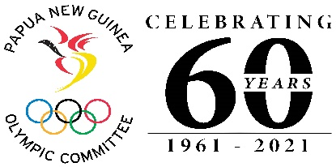

FOR IMMEDIATE RELEASE
Thursday, July 28th, 2021

(Please insert your Trukai high res logo above)

Trukai Fun Run T Shirt Sales Raffle Draw Winners Announced

The Papua New Guinea Olympic Committee (PNGOC) and Trukai Industries Ltd has announced today the 40 winners for the Trukai Fun Run T-shirt Sales Campaign raffles promotions.

The draw was conducted at the PNGOC Office at Olympic Haus Boroko, in the presence of representatives of Trukai Industries Ltd, TSI Security Personnel and PNGOC to witness the occasion.

PNGOC Corporate Manager Ian Leklek congratulated the winners and thanked them for supporting Team PNG through the purchase of Trukai Fun Run T Shirts despite the tough economic times our country was facing. All Fund’s raised this year went towards supporting Team PNG to the Tokyo 2020 Olympic Games.

“We also acknowledge and thanked Brian Bell Group of Companies, Coral Sea Hotels and Theodist Limited for partnering with PNGOC to provide prizes for this campaign. Thank you very much for your wonderful support”, said Mr Leklek

“Thank you Trukai Industries for being the longest partner with PNGOC through your Trukai spanning over 22 years. As a non-profit organisation, we are indebted and grateful for your continued support”, he said.

Despite the non- staging of the actual Trukai Fun Run event due to restrictions brought on by the pandemic, the organising committee still managed to sell (amount of shirts sold? Trukai to confirm and input) which indeed was a great outcome despite the challenges faced.

The winner’s names will be published through print and social media, as well as contacted personally to advise them through the contact details provided on the raffles ticket butts.

END. //

###

