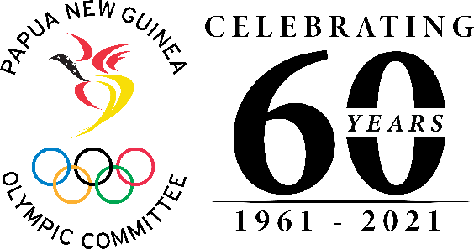
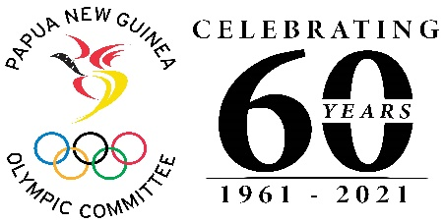

FOR IMMEDIATE RELEASE
Friday, 09 July, 2021

CPL supports Team PNG with Hygiene Packs

The City Pharmacy Group of Companies Ltd has presented hygiene packs to Team PNG’s athletes and officials who will be attending the Tokyo 2020 Olympic Games.

Chief Executive Officer of the CPL Group Navin Raju made the presentations to the Papua New Guinea Olympic Committee (PNGOC) and Team PNG today at the CPL Waigani Central Mall.

Aspiring Olympian, John Ume who will be attending his first Olympic Games in Tokyo, and the only athlete still in-country was present to receive the hygiene packs on behalf Team PNG.

Competing in the 57-63kg Lightweight division, Boxer John Ume will become PNG Olympian number 065 when he gets to debut at the Games later this month.

Secretary General of PNGOC Mrs Auvita Rapilla welcomed the timely assistance and thanked the Management and Board of the CPL Group for the kind donation.

“Your support will go a long way in ensuring our athletes perform to the best of their ability against the top athletes in the world in their various sport”.

“We understand that health and hygiene is important to any individual and with the pandemic still a concern to our society, the hygiene packs will definitely ensure our Team are protected”, Mrs Rapilla said.

Chef de Mission, Tamzin Wardley also conveyed her gratitude to the CPL Team for this timely assistance and acknowledged the company’s continued support to the PNGOC and Team PNG and also sports in Papua New Guinea

END.
###

