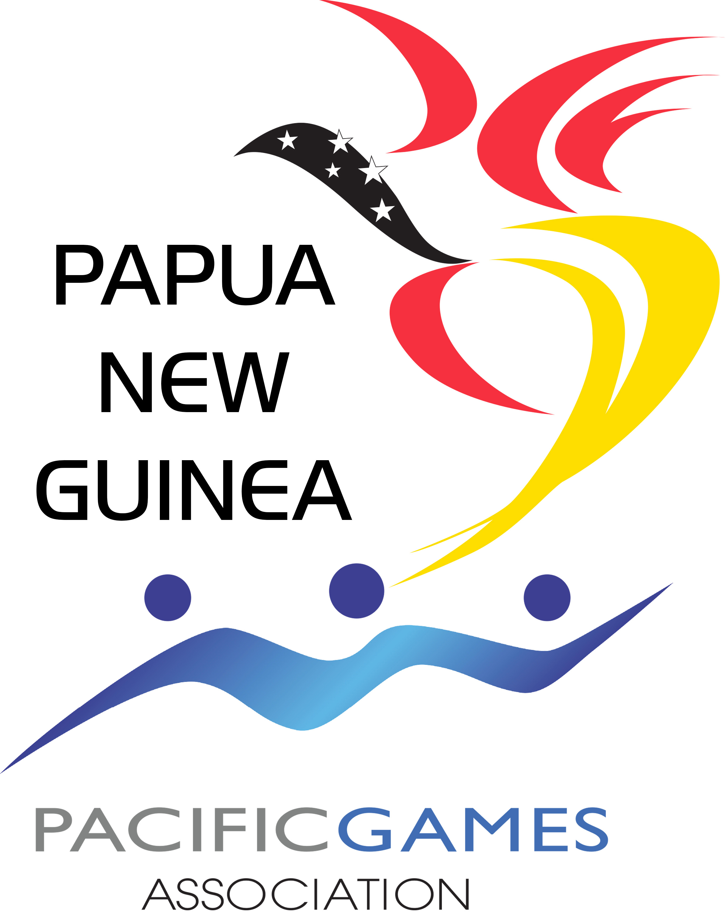

_______________________________________________________________________________________________________________________________________________________
General Management Team Nomination Form

Please complete and return to the PNGOC office by Friday, 25 May 2018
Ensure that all relevant documents are attached and copies of passport, 2 reference and soft copy of ID photo are included.

Date: Date

2019 Pacific Games – Samoa, Apia

Available to travel: ☐ Yes ☐ No

Attachments: ☐ Curriculum Vitae
☐ References
☐ Passport bio page (soft copy, please attach on 3rd page of this form)
☐ ID Photo (soft copy, please attach on 3rd page of this form)
__________________________________________________________________________________

CANDIDATE DETAILS (as on passport)

Title: | Select Title |  | First Name: | Enter your name as shown on passport |  | Last Name: | Enter surname as shown on passport

Date of Birth: | Click enter birth date |  | Gender: | Select gender

Address: .. | Postal Address
Suburb: | Residing suburb |  | Province: | Residing province |  | Post Code: | Provincial post code

Email: | Enter email address |  | Phone: | Enter landline # |  | Mobile: | Enter mobile #

Nationality: | Nationality |  | Country of Passport: |  | Country of passport
Passport No.: | Passport # |  | Expiry Date: |  | Click to enter exp. date.

POSITION APPLYING FOR:

☐ General Manager |  |  |  | ☐ Deputy General Manager
☐ Administrative Personnel |  |  |  | ☐ Operations Personnel
☐ Team Doctor |  |  |  | ☐ Physiotherapist
☐ Massage Therapists |  |  |  | ☐ Photographer/ reporter
☐ Press Attaché |  |  |  | ☐ Sports Psychologist
☐ Photographer/ reporter

BACKGROUND

Have you previously held a similar position in sports in PNG before: ☐ Yes ☐ No

If “Yes”, please give details

Provide details.

Why do you wish to apply for this position?
Reason for applying

QUALIFICATIONS

Date of Course: | Course date |  | Course Provider: | Name of course provider
Qualification: . | Qualification obtained

Date of Course: | Course date |  | Course Provider: | Name of course provider
Qualification: . | Qualification obtained

Date of Course: | Course date |  | Course Provider: | Name of course provider
Qualification: . | Qualification obtained

Other Qualifications: | Qualification obtained

PREVIOUS HISTORY

Position: . | Position title |  | Team: | Name of Team involved with
Year/s (eg. 1999): | State year/s position was held |  | Tournaments/ Events: | Name of tournament/event

Position: . | Position title |  | Team: | Name of Team involved with
Year/s (eg. 1999): | State year/s position was held |  | Tournaments/ Events: | Name of tournament/event

Position: . | Position title |  | Team: | Name of Team involved with
Year/s (eg. 1999): | State year/s position was held |  | Tournaments/ Events: | Name of tournament/event

Other Relevant Experience
Other relevant experience

Are you related to any member of the National Federation responsible for any sports on the program of the Games you are applying for? ☐ Yes ☐ No

If “Yes”, provide name and position: | Enter name and position of NF member

ATTACHMENTS
- Copy of Passport Bio Page 2. ID Photo

Terms
- You agree to continually grow and develop your skills relating to the position you are applying for;
- You agree that the information you have provided is true and to the best of your knowledge;
- You will advise the PNGOC should any of the information provided change;
- This application does not guarantee your selection. Successful appointment will require candidate to sign the Team PNG agreement form and abide by its terms and conditions.

