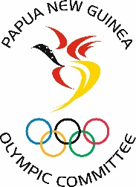
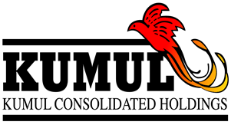

FOR IMMEDIATE RELEASE
Friday 16 July 2021

KCH partners with PNGOC to fund Team PNG’s new Performance Strategy

Kumul Consolidated Holdings is the latest organisation to partner with the Papua New Guinea Olympic Committee in the sponsorship of Team PNG.

The partnership is valued at K3 million, spread over three years from 2021 to 2023. The funding will support the implementation of Team PNG’s new Performance Strategy 2021 – 2024.

This strategy includes PNG’s representation at the Tokyo 2020 Olympic Games, 2022 Birmingham Commonwealth Games, 2023 Solomon Islands Pacific Games and the 2024 Paris Olympic Games.

The Minister for State-owned-Enterprises and responsible for KCH, Hon. William Duma, LLB, LLM, CMG, MP said he was excited to collaborate with PNG Olympic Committee and Team PNG, saying “On behalf of the Ministry of State Enterprises, Board and the management of KCH, we are extremely proud to partner with the Papua New Guinea Olympic Committee and Team PNG.”

“Sport can assist in uniting our nation and we are excited to join Team PNG on this journey. Sports contributes meaningfully to development at all levels of society and our collaboration with Team PNG and PNGOC provides a platform to further develop our youth and communities.”

In welcoming KCH as a partner, PNGOC President Sir John Dawanincura thanked the Minister, Board and the Management of KCH for its commitment to support Team PNG for the next three years.

Sir John said, “We are extremely grateful and excited about this new partnership with KCH. This is the largest sponsorship for PNGOC to date and will ensure the implementation of Team PNG’s Performance Strategy. PNG athletes and coaches will be well prepared and supported to achieve maximum performance in multi-sport competitions over the next three years.”

“Preparations at the elite level is a continuous effort and we are grateful that this partnership will enable us to assist athletes to bring success to the country and inspire more Papua New Guineans to pursue their dreams - just as our athletes pursue their Olympic dreams.”

“Seeing our athletes perform and excel on the international stage brings joy and pride to all Papua New Guineans. Seeing our athletes fly the national flag and bring success to the country will lift the spirits of millions of Papua New Guineans, especially in these Covid pandemic times.” Sir John said.

Ends.

