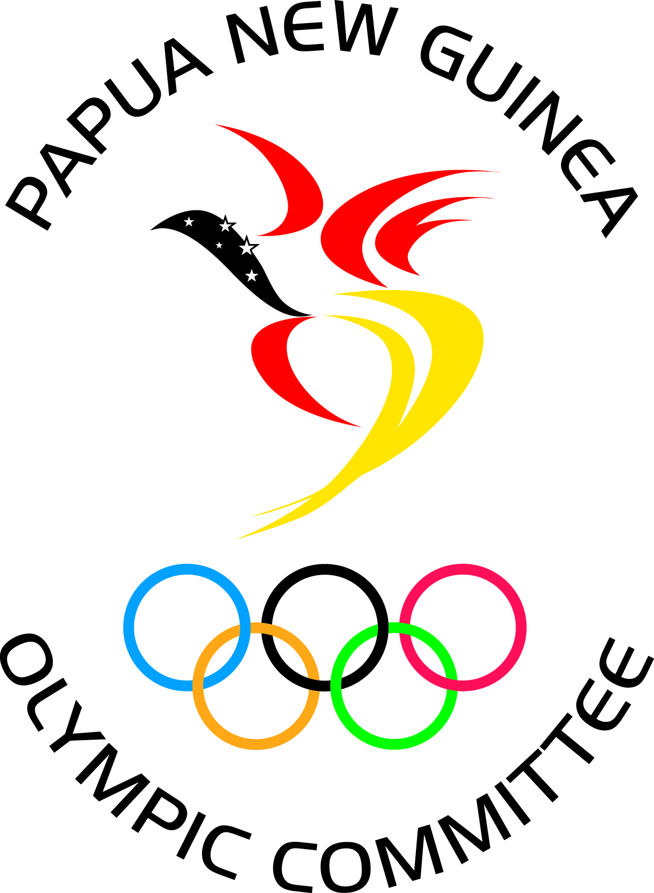

PNG National Federation High Performance Planning Template

2021-2024
Please complete the checklist below, which are minimum requirements for receiving High Performance (HP) support from PNGOC. Please note that if you are unable to provide details for all of the following you will need to discuss this with PNGOC.

Name of NF
Date of last national championships or equivalent
Date of last Annual General Meeting (AGM)
Amount of funding currently/last received from PNGOC
Amount of funding currently/last received from other sources (amount and source)
List stakeholders directly involved in generation of this plan

Values of the HP Plan

List down at least three (3) values of this High Performance Plan

Values

Performance History
Please attach performance history from major international overs over the previous 4-5 years.

Please tick performance history provided for the following Games:

Multi-Sport Games:
☐ 2019 Samoa Pacific Games ☐ 2018 Gold Coast Commonwealth Games ☐ 2016 Rio Olympic Games
☐ 2017 Vanuatu Pacific Mini Games ☐ 2017 Bahamas Commonwealth Youth Games ☐ 2018 Buenos Aires Youth Olympic Games

Sport Specific:
☐ World Championship/Cup ☐ Regional Championships ☐ National Championships
☐ Other: ____________________

Strengths, Weaknesses, Opportunities, Threats (S.W.O.T)
List up to, but no more than three (3) Strengths, Weaknesses, Opportunities and Threats of your high performance program. (Note: These should align with the Programs/Activities/Events that you include in your high performance plan.

STRENGTHS

WEAKNESSES

OPPORTUNITIES

THREATS

Goals
Please list your objectives and Goals for HP over the period of this plan. As per the High Performance Plan Guidelines, this MUST include OUTCOME Goals, PERFORMANCE Goal(s), but may also include PROCESS Goals and an OVER-ARCHING goal. Please ensure that these objectives are achievable, have clear performance indicators or outcomes associated with them and have a timescale for when the outcome(s) is expected to be met. (The table can be expanded to set out as many objectives as necessary).

Games refer to Team PNG games (Pacific Games, Commonwealth Games, and Olympic Games etc.). Only complete if your sport is on the program for the respective Games.

2022 Commonwealth Games (Birmingham, UK) | 2022 Pacific Mini Games (NORTHERN MARIANA ISLANDS)
Insert Outcome Goals here | Insert Outcome Goals here

2023 Commonwealth Youth Games (TRINIDAD & TOBAGO) | 2023 Pacific Games (SOLOMON ISLANDS)
Insert Outcome Goals here | Insert Outcome Goals here

2024 Olympic Games (Paris, FRANCE)
Insert Outcome Goals here

Performance Goals
Performance Goal(s) | Performance indicator | Timescale

Process Goal(s) (Optional) | Performance indicator | Timescale

5. Programs, Activities, Events (hereafter called ‘Programs)
Please list the Programs, Activities and Events that you will undertake to enable you to achieve the goals listed in Section 4 above. Please list intended competitions separately in section 6 below.

Add more rows in the table below if necessary.

Program Name | Brief description or outline of Program | Key Program Outcomes (KPO)
ATHLETE DEVELOPMENT:
COACH DEVELOPMENT:
COMPETITION MANAGEMENT:
Domestic:
DAILY TRAINING ENVIRONMENT
GOVERNANCE/MANAGEMENT
SPORTS SCIENCE / SPORTS MEDICINE

6. Targeted competitions that will help achieve objectives.
Please set out the competitions you wish to target as important and the activities associated with these, such as training camps and attendance at other competitions. (The table can be copied to allow you to target as many competitions as appropriate).

Identify the benchmark competition(s) separately to other key competitions. Benchmark competitions are major competitions such as World Championships, regional competitions, major qualification events or their equivalent. Other key competitions are those in which you intend or propose to participate, but are not necessarily the primary performance target of this plan.

Benchmark Competition(s) | Location and date | Key Performance Outcome | Other activities required to support this event (e.g. SS/SM support, pre-training camp etc.)

Other supporting/key Competition(s) or Training Camps | Location and date | Key Performance Outcome | Other activities required to support this event (e.g. SS/SM support, pre-training camp etc.)

7. Athletes and officials
Please provide details of the athletes and officials you identify as being important to delivering your HP objectives. You also need to provide a rationale for why you have identified these people. (The table can be expanded to set out as many athletes/officials as necessary).

Name of athlete | Rationale | Role/Position/Discipline

Name of official | Rationale | Role

8. Budget
Please provide an indicative budget for achieving your KPOs broken down into areas that address the information you have provided above. (Please expand the table to set out as many recommendations as necessary).

Funding required for: | Details | Amount requested
ATHLETES:
COACHING:
COMPETITIONS
Domestic
International
DAILY TRAINING ENVIRONMENT
GOVERNANCE/MANAGEMENT
SPORTS SCIENCE / SPORTS MEDICINE

Other funding source: | Amount of support (Provide details of non-financial support)

Checklist

NF High Performance Plan Checklist
Plan element | Completed or included in plan (YES/NO)
Alignment to overall NF strategic plan
Stakeholder input
Values of HP Strategy
Performance History
SWOT
Goals
Programs/Activities/Events
Key Program Outcomes (at least 1 for each Program/Activity/Event)
Camp and competitions identified (including benchmark events)
Key Performance Outcomes for camps and competitions
Long list of Athletes and Officials
Budget
Monitoring & evaluation process
Evidence provided

Name of person completing form:
Signature:
Name of PNGOC staff
Signature
Date:

