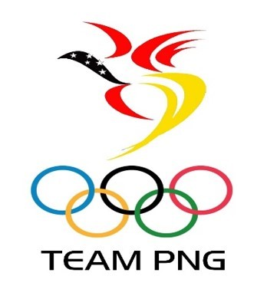
_______________________________________________________________________________

Officials’ Nomination Form

Please complete and return to the PNGOC office by deadline SEPTEMBER 11th 2020.
Ensure that all relevant documents are attached and copies of ID and 2 references are included.

Note: In line with the Team PNG Official’s Selection Policy, candidates should NOT be a National Federation Executive Member. If a candidate is a member of the National Federation Executive, holding a position other than that of President, then a strong justification must be presented along with this nomination form for Justification Committee consideration. The JC in extenuating circumstances may agree to provisionally endorse an Executive Committee member with final endorsement coming from the PNGOC Executive Board.

Games: ______________________________________________________________________
(please list the Games being nominated for above)

CANDIDATE DETAILS

Title (please circle) Mr Mrs Miss Ms Dr

First Name:__________________________ Surname:_________________________ as on passport

Address:_______________________________________________________________________

Suburb:________________________________________________________________________

Province:_______________________________

Postcode:_______________________________

Date of Birth:____________________________ Male Female

Email address:_________________________________ Phone:___________________________

Nationality:______________________________ Country of Passport:_____________________

Passport Number:______________________________ Exp date:_________________________

Driver license number:__________________________ Exp date:_________________________

(Provide photo copy of passport and driver license)

Sport nominating for: __________________________________________________________

Men ____ Women ____ Mixed ____ What team/event: ________________
Position nominating for (number in preference 1, 2 & 3)

Head coach Assistant coach Development coach

Manager Assistant manager Team trainer

Other position: ___________________________

Have you held a previous position in sport in PNG before? Yes No

Give details: _____________________________________________________________________

Why do you wish to nominate for this position in your chosen sport?
________________________________________________________________________________

________________________________________________________________________________

________________________________________________________________________________

Qualifications: ___________________________________________________________________

Date of course: ____________________ Course provider:________________________________

Qualifications: ___________________________________________________________________

Date of course: ____________________ Course provider:________________________________

Qualifications: ___________________________________________________________________

Date of course: ____________________ Course provider:________________________________

Other Qualifications: ______________________________________________________________

________________________________________________________________________________

Previous Coach/Manager/Trainer history

Position: ______________________________Team:_____________________________________

Year/s: __________________________________________________________________________

Tournaments/ Events: _____________________________________________________________

Position: ______________________________Team:_____________________________________

Year/s: __________________________________________________________________________

Tournaments/ Events: _____________________________________________________________

Position: ______________________________Team:_____________________________________

Year/s: __________________________________________________________________________

Tournaments/ Events: _____________________________________________________________

Other Relevant Experience: ________________________________________________________

________________________________________________________________________________

________________________________________________________________________________

________________________________________________________________________________

________________________________________________________________________________

Have you ever been removed from a position before? Yes No

If Yes, please explain: _____________________________________________________________

________________________________________________________________________________

Is it possible that you will be required to Coach/ Manage a relative in the team? Yes No

Are you related to member of the National Federation responsible for your chosen sport?

No Yes If yes, provide name and position: ______________________________________

What is your availability on a weekly basis to perform your duties leading into the nominated Games?

0-8Hrs/week. 8-12hrs/ week. 15+hrs/ week. 25+hrs/ week. Full time

By signing here, you agree to the follow terms.

You agree to continually grow and develop your skills relating to your position.
You agree that the information you have provided is honest to the best of your knowledge.
You will advise the Selection Panel should any of the information provided change.
This nomination does not guarantee selection. Successful appointment will require candidate to sign Team PNG agreement form and abide by its terms and conditions.

Name: |  |  | Witness Name:
Signature: |  |  | Witness Signature:
Nomination approved by NF President:
(Name and signature)

